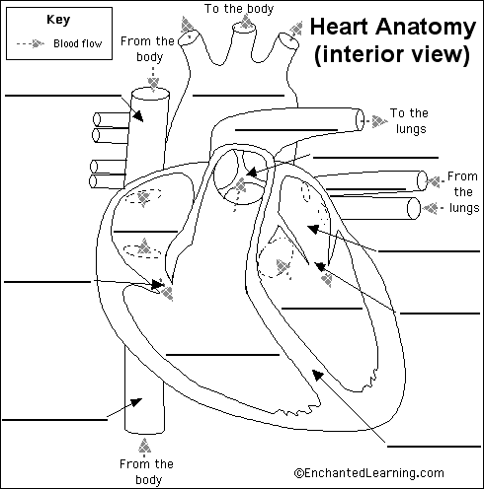

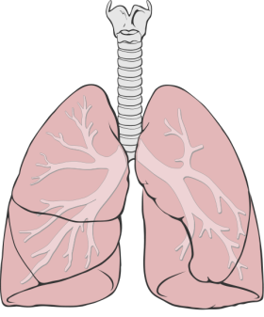
Superior Vena Cava
Aorta
Pulmonary Artery

Valve
Pulmonary Vein
Valve
Right Atrium
Right Ventricle
Valve
Inferior Vena Cava
Left Atrium
Septum
Left Ventricle



